**Functional design Copodi Gaming™**

**Project: protask rpg**

**Client: Stijn van Gemert**

**Projectnumber: 1**

**Auteur: Alexander Deelen & Peter Janssen**

**Date: 19-11-2019**

**Version: 1.0**

The undersigned declare their agreement with the content of this functional design.

**Client Projectmanager**

***Initial Seen: Initial Seen:***

Date: <Geef de datum op.> Date: <Geef de datum op.>

Place: <Geef de plaats op.> Place: <Geef de plaats op.>

Functional design document

Inhoud

PROJECT MANAGEMENT 2

PROJECT DETAILS 2

PROJECT DESCRIPTION 2

REQUIREMENTS 2

CONTENT OF A REQUIREMENTS DOCUMENT 3

USE CASE DIAGRAM AND SCENARIOS 3

WIREFRAMES 4

PERSISTENT DATA 4

APPENDICES 5

APPENDICE A 5

# PROJECT MANAGEMENT

The members of the project are Alexander Deelen and Peter Janssen. Our responsibilities are portraited in the planning(see picture below).

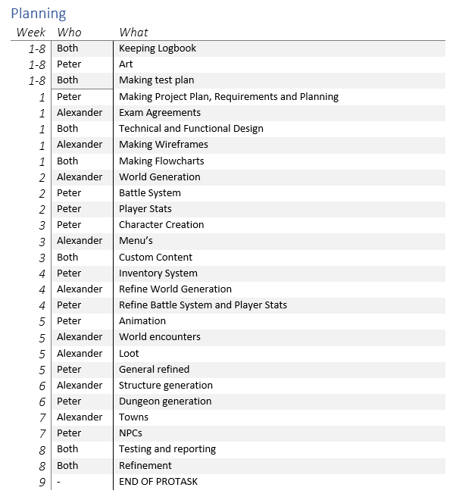

We will be communication to each other mostly through mouth to mouth and else we would be communicating through WhatsApp or discord.

We will have regular meeting at the beginning of the day. And once in the week with the client

# PROJECT DETAILS

Our project is called protask rpg we will be making this for our client Stijn van Gemert and will be done by Alexander Deelen and Peter Janssen.

# PROJECT DESCRIPTION

The project is a rpg game with a world that is randomly generated where you can walk around and encounter enemies which you must fight. The game is customizable, as you will be able to add your own enemies and music. You also be able to make your own character.

The intention of this project is to learn to use Unity to develop a game and with that to expand our knowledge of the programming language we will be using called c#.

# REQUIREMENTS

**Must**

• Japanese-style Role Playing Game (JRPG)

• World procedurally generated

• Battle System

o Actions

* Attack (Weapon)
* Abilities
* Magic Spells
* Items
* Defend
* Run

o Turn-based, greatest speed first

• Customizability

o Custom Music

o Custom Enemies

o Character Creation

• Inventory System

o Consumable Items

o Equipment

• Player Stats

o Attack, Defense, Magic, Speed, Luck

o Experience System with level-ups

o Classes

* Classes determine stat growth
* Classes have special properties (Magic Spells and Abilities)

**Should**

• No Random Battles in the overworld

o Enemies appear on screen, walk into them to start battle

• Battles have animation

o Enemy idle

o Enemy attack

o Player attack

• Get more Items

o Enemy Loot

o Treasure Chests in the world

**Could**

• Dungeons and Structures

o Random Buildings throughout the world

* Towns Possible, low priority

o Dungeons aside from main world

* Separate Procedural generation

**Won’t**

• Use templates

• Static World

• Make Apple Version

# USE CASE DIAGRAM

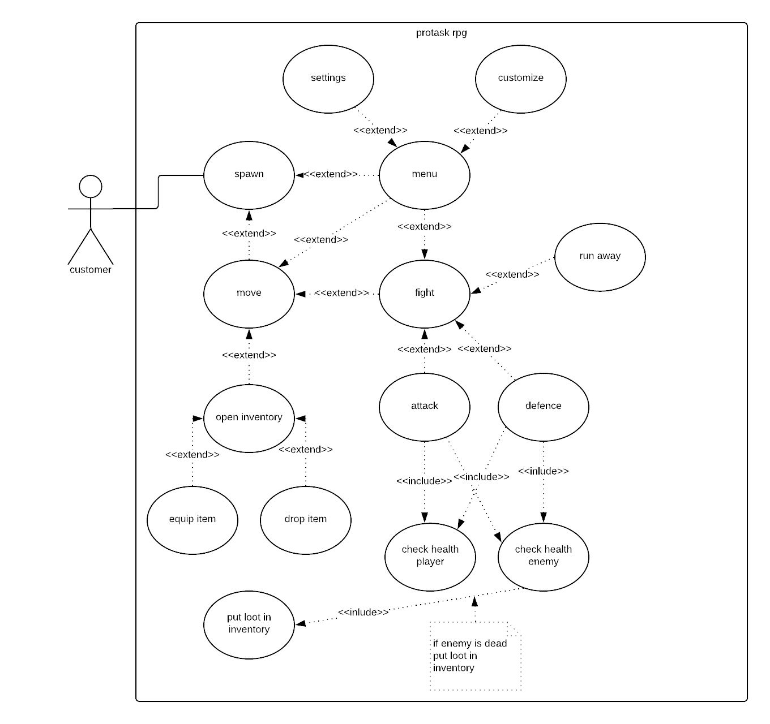

# WIREFRAMES

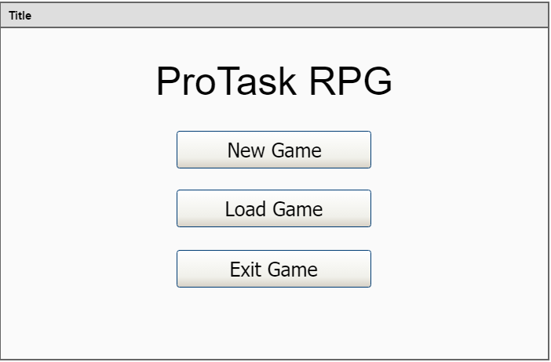

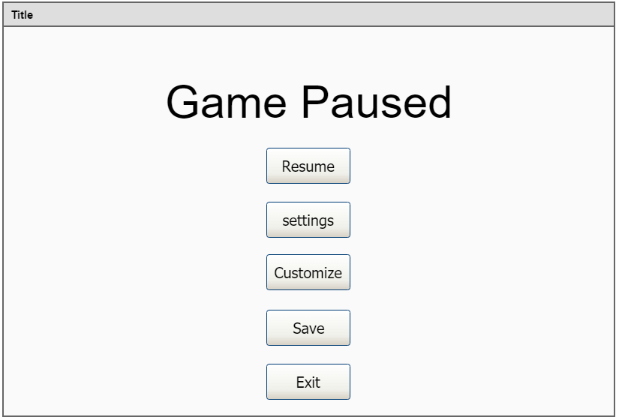

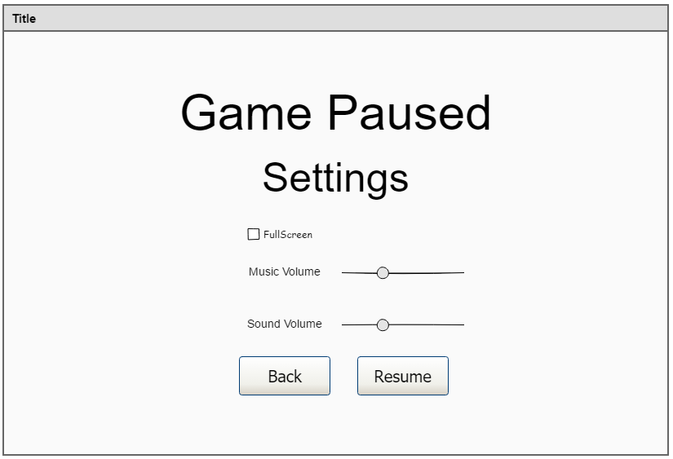

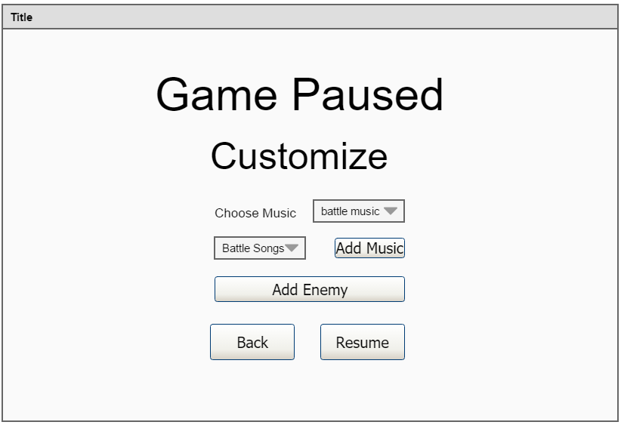

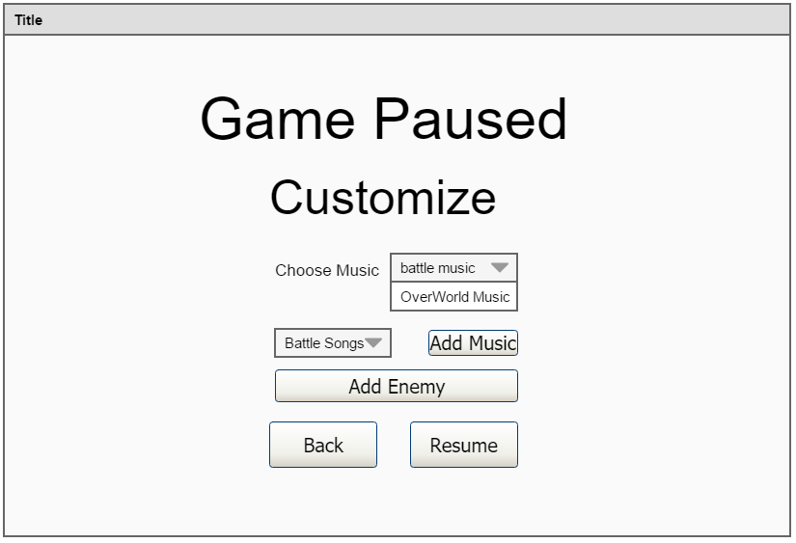

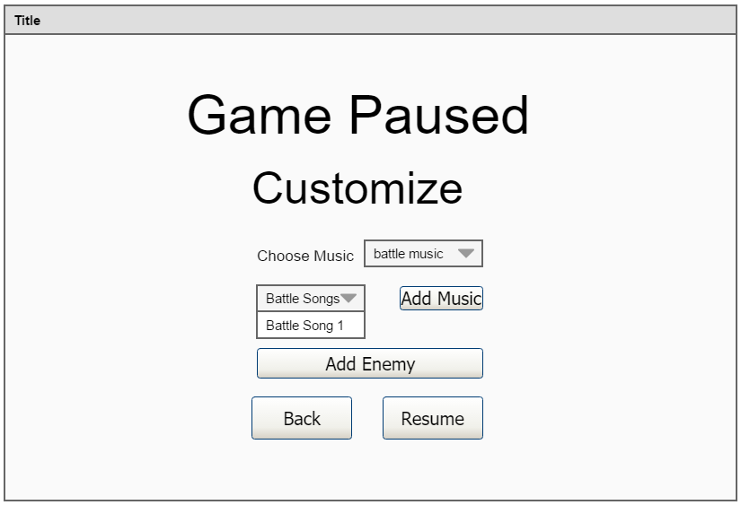

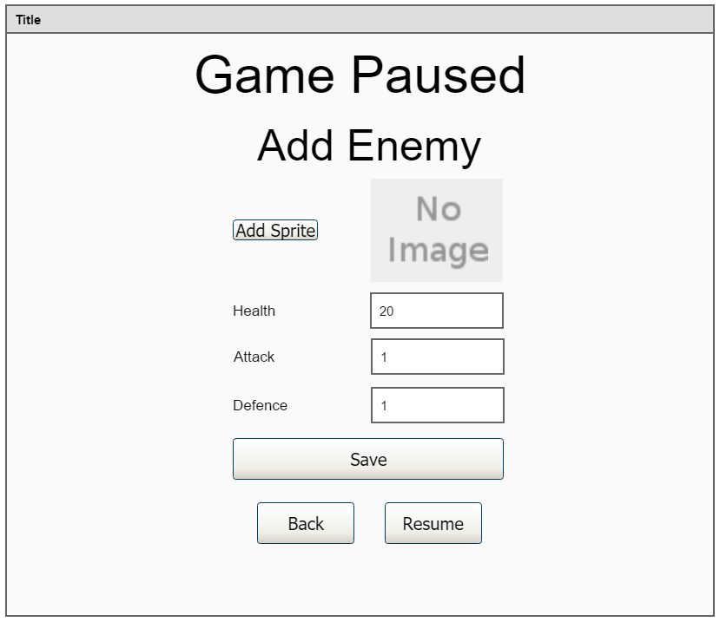

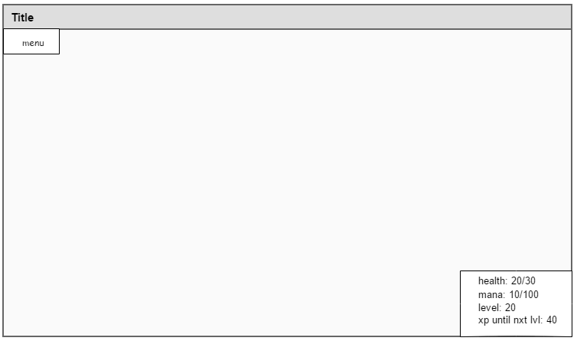

Picture above is the hud screen.

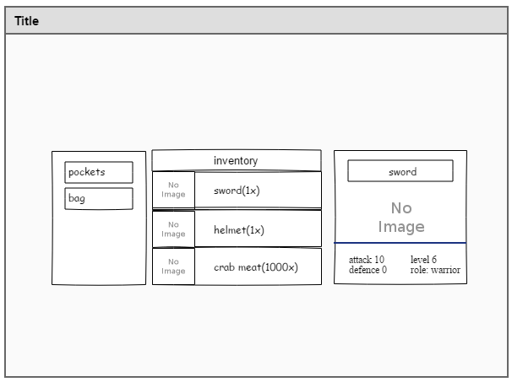

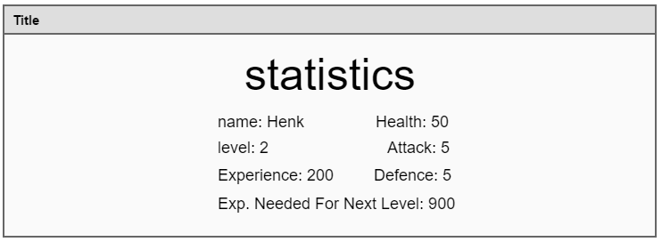

# What do we need?

We will be needing a laptop with Unity and visual studio installed on it. We also need to have installed the unity tools for visual studio. We also will be needing GitHub to make sure we can both work on the project.

We both have installed everything needed and have tested it with making the 2d platformer tutorial of unity. We also have opened visual studio to test if we could program the 2d platformer tutorial game to see if everything works alright.

We are using version 15.9.17 of the 2017 edition of visual studio. We will be using Unity version 2019.2.13. we are using the default settings.

# APPENDICES

## APPENDICE A

Approval.

If You agree with the content of this Functional Design Document, please return a signed copy of it.